OKEECHOBEE ACHIEVEMENT ACADEMY
Bryan VanCamp, Principal
1000 NW 34th Street, Okeechobee FL, 34972
Phone: 863-462-5125 Fax: 863-462-5295

Parent-School Compact

PARENT/GUARDIAN AGREEMENT
I want my child to succeed; therefore as a parent/guardian, I will be responsible for the following:
- Providing an environment that promotes learning.
- Seeing that my child is on time and attends school regularly; notifying school if my child is absent.
- Interacting with and supporting my child (listening to their needs and concerns).
- Working with my child in developing and striving toward future goals.
- Participating in school activities, such as parent informational meetings and parent-teacher conferences.
- Asking teachers or other school personnel for help when needed.
- Cooperating with the school on disciplinary matters.

STUDENT AGREEMENT
As a student, I will become an active partner in my learning by:
- Arrive to school on time and attend school regularly.
- Complete assignments with pride and perseverance.
- Arrive on time to classes and be ready to learn.
- Cooperate with parents/guardians, teachers, and OAA faculty.
- Respect the personal rights and property of others.
- Be of service to those in need.

SCHOOL AGREEMENT
The school will be responsible for the following efforts in helping every student succeed:
- Build supportive relationships with students and families.
- Provide parents/guardians with regular reports on their child’s progress and keep an open line of communication
- Maintain high expectations for students, academically, socially, and behaviorally.
- Welcome the participation of parents/guardians in the classroom and their support in helping their child achieve
- Promote a supportive, safe and effective learning environment that enables the students served to meet the student performance standards

Parent/Guardian Signature Date

Student Signature Date

Principal Signature Date

O keechobee Achievement Academy
Rao‹fsl Weiguro, Principal
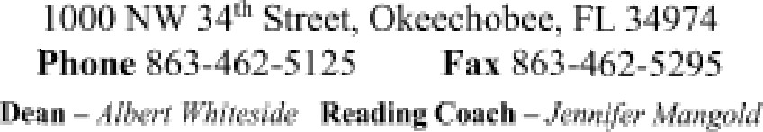
w't:igumr@tikcc.k 1 2.fi uu
Bea9 'ior ialer 'eniipaJ8j - Citi.Grid 6jn‹-

